
1st Floor Weatherwise Building East Cowes PO32 6SP info@phpartnership.com | 01983 216699

BBV SCREENING SERVICE PROTOCOL

Testing

When a client attends the pharmacy requesting testing staff will:

- Introduce themselves to client and give them a copy of the at risk check list to read
- Client must be over the age of 13. If under 16 years they must be Fraser competent
- If the client informs the pharmacist that they feel they have been at risk from hepatitis B and/or C, HIV or Syphilis, the client will then be escorted to the private testing room (clients with no obvious risk factors should be advised that testing is not required).
- Please ensure all confidential discussions take place in a suitable area of the pharmacy and that all staff area aware of the service and how it must run

Pre-test discussion:

The pharmacist will carry out a pre-test discussion with the clients taking approximately 10 – 15 minutes.
This discussion will:

- Assess the possible risk factors the clients may have that could indicate that they have been exposed to Blood Borne Virus (BBV) or syphilis in the past (clients with no obvious risk factors should be advised that testing is not required).
- Explain possible window period for re-testing if recently been at risk (3 months)
- Give a copy of the pre – test leaflet to the client, available on LPC website – link on service screen
- Outline the blood spot test to the client.
- Advise on what will occur if the client is tested positive for either hepatitis B or C, including direct referral to Hepatology and GP notification. HIV positives and Syphilis positive patients will be referred by secure messaging to the Sexual Health Service, St Mary’s. For IDAS clients, in addition to referral, a notification will be sent to IDAS. This again is automatic. See flow chart
- Explain that both Hepatitis B and C can lead to severe liver damage and an increased risk of liver cancer. However there is effective treatment available for both viruses. Hepatitis B treatment can suppress viral activity and prevent liver damage. Hepatitis C treatment can clear the viral infection completely. Medical advances now mean a much higher chance of complete cure than ever before. Regarding HIV, early diagnosis means better chance of managing infection, syphilis can be treated.
- Explain that if the client is tested positive for Hepatitis B, HIV or Syphilis your family members (Partner and potentially children) will need testing and vaccination:

- The procedure for results giving will be explained and a mutually convenient follow-up appointment will be made at the pharmacy 2 weeks later.

For Hepatitis B and C and HIV

- Explain that positive test results may have implications on life insurance and therefore mortgages, as is common with many chronic (long term) illnesses.
- Explain that the test is confidential and that the information that they choose to give the staff will be covered by the data protection act.
- Explain that information will be recorded on PharmOutcomes for each client for reference and audit. Client’s personal details / information will only be accessible by staff undertaking the testing, analysis and for audit purposes. This information will be kept securely in order to maintain strict confidentiality. This information will not be shared with the clients GP without their consent. Audit information will be compiled but this data will be anonymous.
- The pharmacist will answer any questions the clients may have.

Consent:

The pharmacist will confirm that the client is happy to give their consent to be tested. This is recorded on PharmOutcomes.
The client will also be asked to give consent to a GP notification that will be sent by secure messaging if they are tested positive for either hepatitis B or C, HIV or Syphilis.

Consent is also required for notification of results – stage 2 – see flow chart (appendix 1) All consents are captured and recorded at stage 1 of service delivery.
No notification or referrals will be sent if negative results are returned.

Testing Room:

The testing room will need to be private and will have hand washing facilities. The room will be prepared by the pharmacy staff.

Equipment required:

- Disinfecting spray
- Paper towels / tissues
- Surgical gloves
- Cotton wool swabs provided by pharmacy. Blood spot testing kits (including safety lancet, blood spot testing cards, plastic/paper sleeve and prepaid envelope, alcohol swabs, waterproof plaster). – provided by Isle of Wight Local Authority
- Sharps containers
- Plastic waste disposal bags for incineration

Blood spot test:

- The staff will wash their hands. See guidance below

STEPS TO SUCCESSFUL DRIED BLOOD SPOT COLLECTION

BEFORE YOU BEGIN

- Lay out the lancet, blood spot collection card, cotton wool, alcohol swab and plaster.
- Check the location of the nearest sharps bin.
- Write participants name and/or centre ID, DOB and collection date on the blood spot card.
- Put on a pair of disposable gloves. These should be worn for the whole procedure to protect you and to protect the sample from degradation.

- CHOOSE SELECTED FINGER

  - Choose a finger from either hand. Use one of the outer three fingers avoiding finger pad and nail bed.
  - To help increase blood flow, ask participant to rub their hands together for 10 seconds, or wash their hands in warm water if hands cold. It is important that the puncture site is warm.
  - Then allow hand to hang at their side for 30 seconds.
  - Place the chosen hand with the palm side up on a flat surface or table.
  - Swab chosen finger with the alcohol swab provided and allow to dry.

- REMOVE SAFETY CAP FROM LANCET



  - Break the seal by twisting

- POSITION LANCET FIRMLY ON FINGER



  - Hold lancet steady with the tip of two fingers and place at the puncture site.
  - Gently apply pressure until the lancet is activated. A click sound will be heard when this has happened. The blade will puncture the skin and automatically retract.
  - Safely discard the lancet into a sharps bin.
  - Observe the finger to see if blood is flowing from the incision site.

- GENTLY APPLY INTERMITTENT PRESSURE TO FINGER

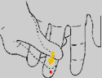

  - Holding hand downward, apply intermittent pressure to finger from palm to fingertip to produce blood.
  - Avoid strong repetitive pressure (milking), it can damage the area.
  - DO NOT squeeze just the finger as this blocks blood flow.

- FILL EACH CIRCLE


  - Wait until the drop of blood is large and hanging. Allow blood to drop onto filter paper or carefully touch the filter paper with the drop. Use 1-2 drops of blood to fill each circle.
  - Ensure ALL FIVE circles are filled to their perimeter and that the paper is saturated.
  - Once all circles are filled give participant cotton wool to hold to puncture site until bleeding stops and apply plaster.

- LET SPOTS AIR DRY

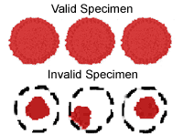

  - Leave collection card open to allow blood spots to dry.
  - Once dried and without touching the filter paper, close the card and place it into the plastic envelope provided (attached to the test request form).
  - Along with the card there should be one bag of desiccant within the plastic envelope.

- COMPLETE PATIENT REQUEST FORM

  - Complete the test request form. Check all the required details are entered
- POST SPECIMEN TO LABORATORY

  - Post sample with accompanying request form to the laboratory in the pre-paid envelope provided.

Reporting – registration and test – Stage 1

  - The client registration and test will be recorded on PharmOutcomes for reference, audit and pharmacy claim, ensure this is completed whilst patient facing as you must collect consents.
  - Please observe the requirement to check Fraser competency for those presenting under the age of 16 years.
  - Used cotton wall balls, surgical gloves and all other equipment will be placed in plastic waste disposal bag for incineration.
  - The area of testing will be disinfected with disinfecting spray and prepared for next test.
  - The documentation pack will be completed and the pharmacist will check again that the client knows when they need to attend the pharmacy again to receive their results and that they have all the written information they require.
  - Print off the PharmOutcomes “Pharmacy record” that details the date of results delivery and give a copy to the client.

Analysis:

The prepaid envelope containing the testing strips will be posted on the same day as testing.

A written laboratory results report will be returned to the pharmacy by post, characteristically 7 days. The laboratory carries out HPA notification. This is a requirement as Hepatitis is a notifiable disease.

Results Reporting – positive results only – Stage 2

Upon receipt of results, characteristically day 7, report all positive results using stage 2 of the PharmOutcomes service entitled “BBV testing – positive results reporting”. This will generate appropriate referrals to relevant care teams. – see flow chart appendix 1

Client results delivery – Stage 3

Clients will be seen at a pre-arranged follow-up appointment to receive their results 2 weeks later. This appointment will be written on an appointment card generated at stage 1. (Print out from PharmOutcomes at time of test.)
If the client fails to attend the follow-up appointment for results they will be contacted using the preferred method of contact provided at the time of testing. Clients should be encouraged to contact the pharmacy in order to schedule another mutually agreeable appointment time.
Results should whenever possible be given by the pharmacist who undertook the test.

Those clients testing positive for hepatitis C will be given all test results together including antibody result, PCR and genotyping.

For patients returning a positive Hep B result or positive Hep C result that is also PCR +ve, a secondary care consultant will attend the results appointment, effectively making this the 1st secondary care appointment

Documentation

All documentation (client results sheet – appendix 2) must be kept in a safe place in line with information governance policy. Intervention details will be stored on PharmOutcomes and this will be the clinical record. All data MUST be recorded patient facing. Records are retained in line with record retention requirements – 8 years

All notifications will be sent automatically via PharmOutcomes secure email as data is saved. Please take care with IDAS clients as this question answer dictates whether a referral will be sent to IDAS – Only appropriate for IDAS clients, see service screen, stage 2

Delivery of Results

Hepatitis B and C Infection

Positive Results:

As is good clinical practice for any situation where bad news is being conveyed, the result should be given face to face in a confidential environment and in a clear and direct manner. If a patient’s first language is not English, consideration should be given to utilisation of an appropriate confidential translation service.

Advice and information will be given to clients testing positive for any BBV or syphilis infection.

Advice on how to prevent passing infection to other people will be given, with reference to post-test leaflets where appropriate – see links in the side bar of the results service.

With the client’s consent a notification will be sent to their GP showing positive results Referral to the local secondary care, specialist hospital based service is automated for all positive results.

If the client is positive but does not attend their follow-up appointment and does not respond to the reminder, a notification will still be sent via PharmOutcomes with the diagnosis to the secondary care team and their GP if consent given.

If the client is hepatitis C positive:

All positive clients are referred to the Hepatology team as part of the service delivery. This referral will detail the genotype of the infection. A consultant will attend the results session as part of this service delivery.

If the client is hepatitis B positive:

Family members will need testing and vaccination. These include sexual partners,

children living at home and any other family members living in close proximity with the client. Clients should be advised regarding the need for this.
Advise use of barrier methods of contraception / condoms until their sexual partner has been tested and vaccinated or to use condoms if not currently in a stable/permanent sexual relationship.

Negative Hepatitis B or C Result

Recommend re-test if they have been at risk recently (3 month window period).

Give advice on how to prevent contracting BBV’s or syphilis in the future, with reference to pre-test leaflet and the ‘are you at risk’ leaflet – Hep B and C.

If they remain at risk from hepatitis B, recommend a course of vaccination.

HIV Infection

Post-test discussion.

Face-to-face provision of HIV test results is a requirement of this service. This is especially significant for:

- Patients more likely to have an HIV-positive result;
- Those for whom English is a second language;
- Young people less than 16 years; and
- Those that may be highly anxious or vulnerable.

Post-test discussion for individuals who test HIV negative.

It is considered good practice to offer health promotion screening for sexually transmitted infections and advice around risk reduction or behaviour change including discussion relating to post-exposure prophylaxis (PEP) to those individuals at higher risk of repeat exposure to HIV infection. This is best achieved by onward referral to GUM or HIV services or voluntary sector agencies. The need for a repeat HIV test if still within the window period after a specific exposure should be discussed. If a patient tests negative, but has been exposed to risk factors and they present for an HIV test inside of a twelve week window, a repeat test at three months should be recommended.

Occasionally HIV results are reported as reactive or equivocal. These patients may be seroconverting and management of re-testing may be complex. These individuals should be promptly referred to specialist care.

Post-test discussion for individuals who test HIV positive.

If a positive result is being given by a non-GUM/HIV specialist, it is essential prior to giving the result to have clarified knowledge of local specialist services and have established a clear pathway for onward referral. The PharmOutcomes system will have already alerted the Sexual Health service of a positive result when stage 2 of service provision is completed

It is recommended that any individual testing HIV positive for the first time is seen by a specialist (HIV clinician, specialist nurse or sexual health advisor or voluntary sector counsellor) at the earliest possible opportunity. Same day appointments at Sexual Health Service, St Mary’s Hospital can generally be achieved in the majority of cases.

It is imperative that complete stage 2 of this service as soon as results are received thereby ensuring the automatic notification to sexual health services of positive results. More detailed post-test discussion (including assessment of disease stage, consideration of treatment, and partner notification) will be performed by the GUM/HIV specialist team.

HIV testing and insurance.

The ABI code of practice 1994 states that questions regarding whether an individual has ever had an HIV test or a negative result should not be asked. Applicants should however declare any positive results if asked as would be the case with any other medical condition.

Syphilis infection

All clients screening positive to syphilis infection will be referred to the Sexual Health Service, St Mary’s Hospital on completion of stage 2 – results reporting. Information on treatment and the avoidance of transmission should be provided as part of the post-test discussion.

IDAS Clients special consideration

For IDAS clients, a results notifications will be auto-sent to IDAS on saving data at stage 2 of service delivery. It is essential that providers observe care when completing stage 2 of service delivery to identify IDAS clients. Answering yes to this dedicated question triggers an automatic notification of positive results to IDAS.

Record Retention

Under current governance protocols, all patient notes should be retained by the Pharmacy for 8 years.

Audit

This process is automated via PharmOutcomes.

Provider Claims for service delivery

Claims will be managed through PharmOutcomes. This means claims for service provision are generated automatically alongside service delivery, allowing the provider to focus on service delivery.

A fee of £27 will be paid for the completion of a dry blood spot test.

Service evaluation

Some service evaluation questions have been included in stage 3 of this service in order to obtain some client feedback of service experience.

Supplies of Testing kits can be obtained directly from Pinnacle Health LLP. Please email helpdesk@phpartnership.com to order supplies

Appendix 1 – Testing Flow Chart
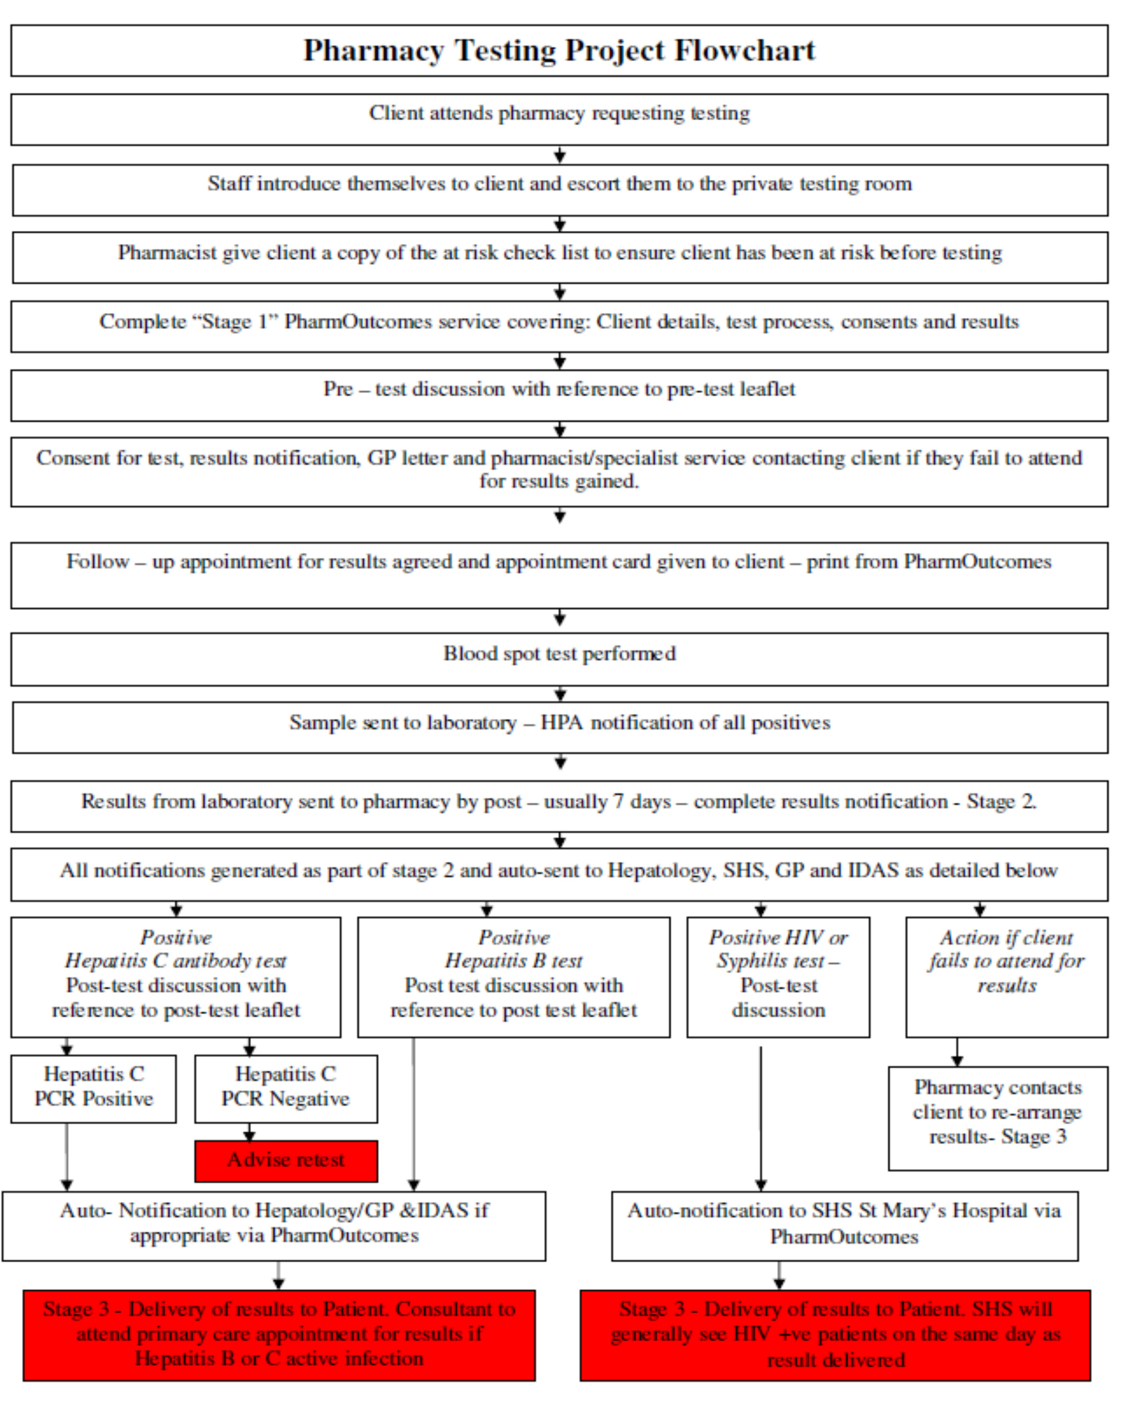

Appendix 2 – Typical results sheet
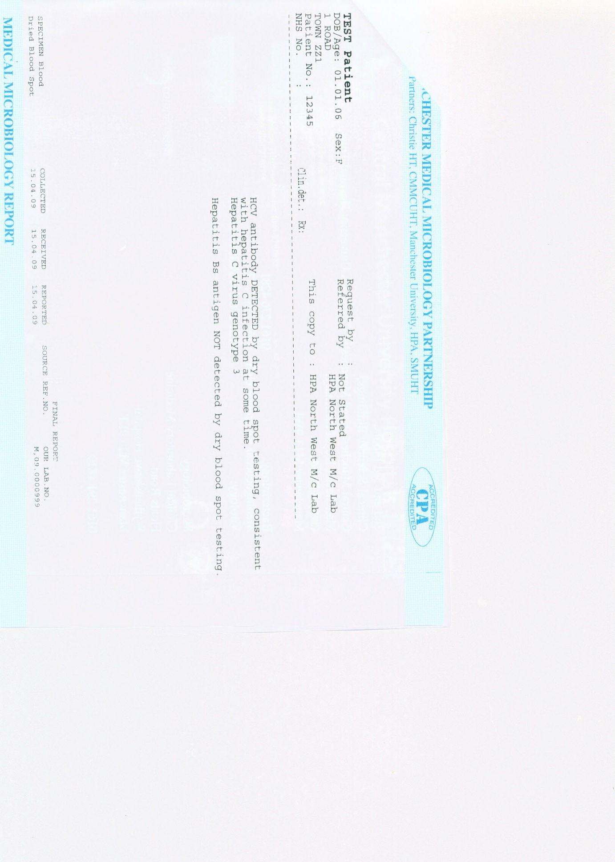

Appendix 3 – Risk Factors
